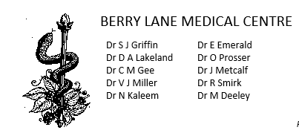
Neurodiversity- Further information

Patient to complete

PATIENT NAME

DOB

ADDRESS

EMAIL ADDRESS

We would be very grateful if you could answer the following questions, providing examples of how you feel impaired, how you have managed/do manage where possible.

1) Describe any difficulties with attention, concentration and memory. e.g. being easily distracted, struggling to concentrate, difficulties following conversations, forgetting appointments or plans, not following conversations, forgetting and losing day to day items.
Childhood | Adulthood
2) Describe any times you have experienced Impulsivity and restlessness. e.g. experiencing high levels of impatience and frustration, risk taking behaviour, using substances, poor sleep, racing thoughts, struggling to relax or sit still and fidgeting a lot.

Childhood | Adulthood

3) Please comment on what impact these difficulties have had on your life. (home, work, education, friendships, relationships, risk-taking, money management etc):

Childhood | Adulthood

